## Fitz

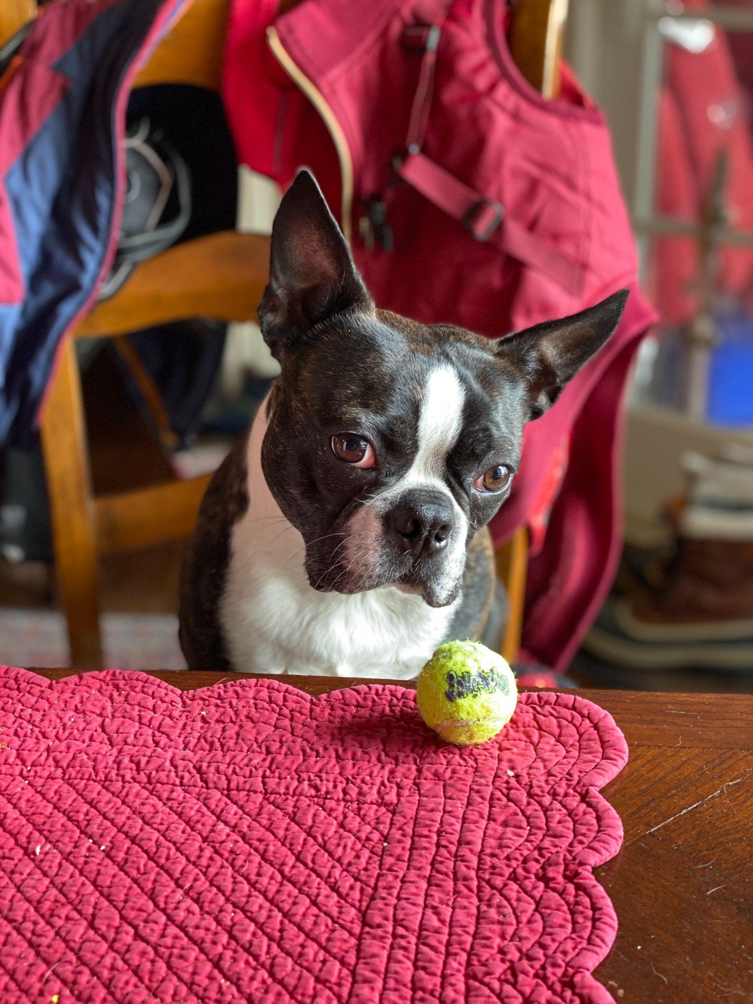

1. Fitz.jpeg
2. Boston terrier watching a tennis ball at the table.
3. Loves chasings tennis balls, chipmunks, squirrels, and birds. Often found sitting by the fire in wintertime, and in sun patches when available. He’s energetic, mischievous, and easily bored. He loves people and gets grumpy if left without a lap too long.
4. Loves barking up trees, running around on the lawn, and digging in the dirt looking for moles. He especially likes getting treats and whines when he comes inside and doesn’t get a snack.
5. **Photo Gallery – (Just write Photo Gallery)**
6. Fitz_standing_on_chair.jpeg
7. Fitz standing on a wooden chair, looking at the camera.
8. Fitz_sleeping.jpeg
9. Fitz sleeping in a fuzzy dog bed.
10. Fitz_on_the_lawn.jpeg
11. Fitz laying out on the lawn in the grass.
12. Fitz_laying_in_bed.jpeg
13. Fitz sleeping with his face buried in a plaid blanket, only his head is visible.
14. **Likes**
15. Blankets
16. Being warm
17. Barking
18. Kay Malan